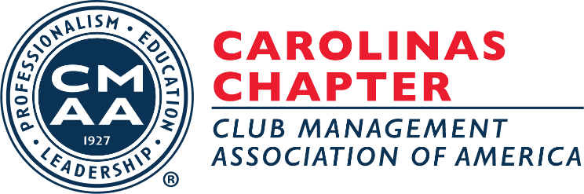

The Carolinas Chapter of the Club Management Association of America

Who We Are
The Carolinas Chapter of the Club Management Association of America (CMAA) is the professional Association for managers of membership clubs. The Carolinas Chapter is comprised of over 400 members, representing more than 150 clubs, within North and South Carolina. As CMAA’s third largest chapter, the Carolinas is very active and proud of the value of the education, networking, and social opportunities offered and afforded to its members.
Given the geography of the Chapter’s two states, Carolinas Chapter members manage clubs ranging from the seasonal mountain and beach clubs to the year-round metropolitan country and golf clubs. Similarly, clubs range from very small seasonal operations to large multi-property facilities, from member-owned to developer-owned, and everything in between.

What We Do
The Chapter’s mission is to provide timely, engaging, and informative education to persons connected with the management of clubs and other associations of similar character; to promote and encourage efficient and successful club management skills; and to advance friendly and mutually beneficial relationships among its members.
Education is the backbone of the Association. In addition to all that is afforded on the CMAA National level, the Carolinas Chapter prides itself in the abundance of valuable, continuous, and ongoing education program offerings, all of which are aligned with what CMAA deems as the ten competency areas of club management and as the requirements to certification.
On an annual basis, the Chapter schedules four quarterly, multi-day meetings and three one-day programs. Additionally, the Chapter is divided into five regions so that managers of clubs of even more similar character and geography can meet and network on a more frequent basis than the full-Chapter events allow.

How We Do It
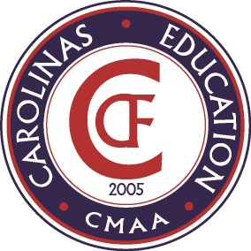
Much of the Chapter’s continuing education is afforded by the Carolinas Club Foundation (CCF) by way of grants and scholarships offered to the Chapter and its members. The CCF was formed in 2005 as a tax-exempt, 501(c)(3) organization for the purpose of financially supporting the professional development of club management through education, training, and research initiatives.
With the initial ambition, hard work and financial support of many – those who are now honored members of the Founders Club – and the ongoing leadership of the CCF Board of Directors, pledges from members and clubs, and sponsorships from corporate vendor partners, the CCF continues to grow in its offerings to and support of the club management industry.

How We Can Partner With You
The Carolinas Sponsorship Program (CSP) is a collaborative effort between the Carolinas Chapter, the Carolinas Club Foundation (CCF), and organizations that have demonstrated an interest in and support of the club industry. The Program is intended to create a bridge between club management professionals and the companies most closely connected with and committed to serving the industry.
The CSP provides companies the opportunity to participate at one of four sponsorship levels: Platinum (two with category exclusivity), Gold (two with category exclusivity), Silver and Bronze. An additional Partner level of involvement is available for those companies wishing to support the Chapter and Foundation but not make a sponsorship commitment.
The CSP offers organizations year-round exposure to club management professionals through sponsorship and marketing packages. In return, each supporting organization makes a one-to-three year commitment to provide the chosen level of monetary support to the Chapter and Foundation. This support will enhance the quality education and programming offered to Chapter members and hospitality students within the Carolinas.

Making Our Chapter Better – Always Improving, Never Settling
CAROLINAS STRONG!

