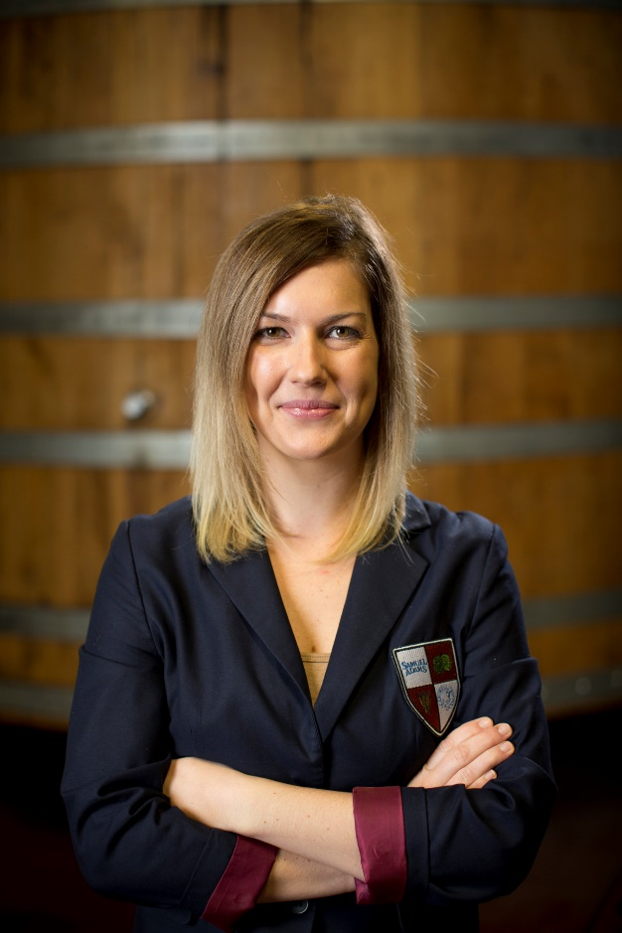
As the Beer Education Manager, Meagen has taken beer training to over 2,500 distributors and retailers across the United States. She is a Certified Cicerone®, a provisional BCJP judge, and active in the homebrew community in Boston. In 2010 she met Jack McAuliffe, who founded the first microbrewery in the United States, New Albion; and in 2013 with the help of Jim Koch, she worked to bring New Albion Pale Ale back to the US market for the first time in over 30 years. When she’s not teaching or trading beers with numerous beer penpals across the country, she is showing off her beer inspired engagement ring and planning a wedding!

